**Leave Management System**

**Objective**

This Project aims to develop an essential online leave management system for the organization. This system automates the workflow of leave applications and their approvals.

The Leave Management System application will reduce paperwork and maintain records more efficiently.

**Requirements:**

1. **Admin:**
   1. When an admin logs in, it redirects to the admin dashboard.
   2. The admin dashboard has a list of applied leaves by all employees with pagination.
   3. The admin should have the authority to approve or decline the applied leaves.
   4. If the Admin declined the leave Admin needs to enter the rejection reason.
   5. Admin will not be able to approve his/her leaves.
2. **Employee:**
   1. When an employee login, he/she will be on the employee dashboard.
   2. On the dashboard, Employees can see their applied leaves with Pagination.
   3. Employees can view their leave details on a new page.
   4. Employees can also apply for leave with dates and reasons.
   5. Employees can also cancel their applied leave and mark the status as Canceled.

**Tools Required**

* Visual code,
* MySQL,
* Xampp,
* GitHub,
* Web Browser

**1. INTRODUCTION**

In the existing paperwork related to Leave management, leaves are maintained using the attendance register for staff. The staff needs to submit their leaves manually to their respective authorities. This increases the paperwork. The main objective of the proposed system is to decrease the paperwork and help in easier record maintenance by having a particular centralized Database System, where Leaves and Notices are maintained. This module intelligently adapts to the management's HR policy and allows employees and their managers to manage leaves and replacements for better workload scheduling.

**Landing Page —** It consists of the **Login Page** to authenticate the user with a username and password.

**DATA FLOW DIAGRAM:-**



**ER DIAGRAM:-**

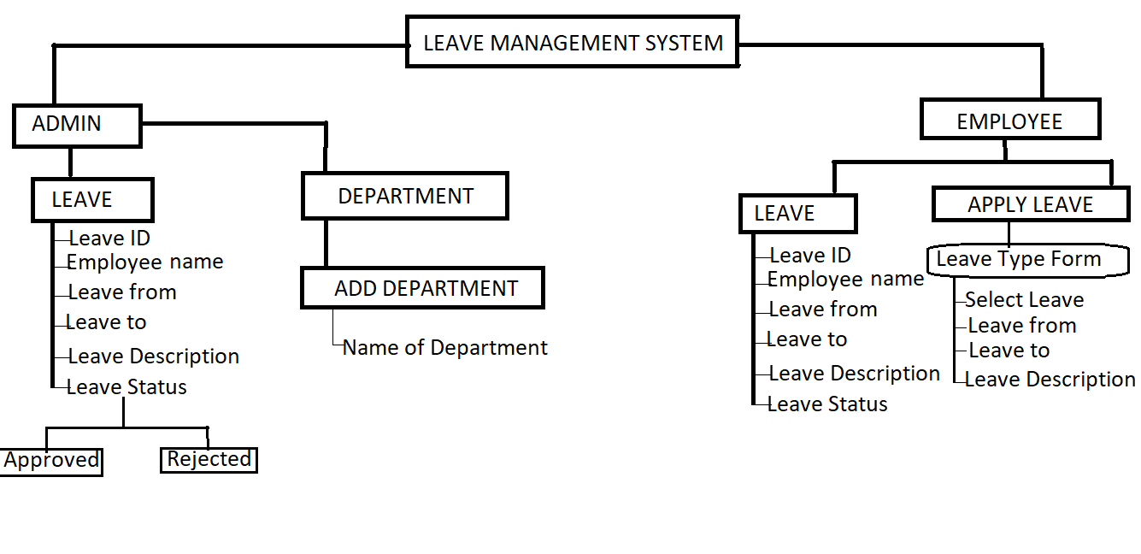

We have created a Leave management system for employees and admins where they can log in on their separate portals where employees can apply for leave and admins can approve/reject the leaves.

# **This collaborative project was completed by a team of 5 Full Stack developers.**

### **Collaborators:-**

* [Falak Chhabra](https://github.com/falak987)
* [Priti Sharma](https://github.com/psvishwakarma)
* [Nikhil Kumar](https://github.com/NIKHILKUMAR-1999)
* [Abhijeet Rajput](https://github.com/Abhijeet61)
* [Shashank Dubey](https://github.com/shashankdofficial)

# **Tech Stack**

* PHP
* MySQL
* Html, CSS, JavaScript

**External Libraries**

**Bootstrap v 4.1.3**

**fontawsome.io**

**normalize.css v8.0.0 | MIT License | github.com/necolas/normalize.css**

[**https://fonts.googleapis.com/css?family=Open+Sans:400,600,700**](https://fonts.googleapis.com/css?family=Open+Sans:400,600,700)

[**http://erikflowers.github.io/weather-icons**](http://erikflowers.github.io/weather-icons)

[**http://www.w3.org/**](http://www.w3.org/)

[**http://simpleweatherjs.com**](http://simpleweatherjs.com)

# **Modules**

* Login Module/ Footer
* Admin Module
* Employee Module
* Apply for Leave

# **Features**

* Data Authentication and Validation for all the users (Admin, Employee)

**Admin Features**

* Admin can Log in/Log-out
* Approve/Reject Leaves

## **Employee Features**

* Employee Can Log in/Log out
* See all applied leaves
* Can apply leave

# **Installation & Run**

* Setup Xampp
* Configure MySQL Database
* Put Project in **C:/xampp/htdocs/lmphp/login.php**
* On the web browser in the URL type **localhost/lmphp/**

**DATABASE SCHEMA:-**

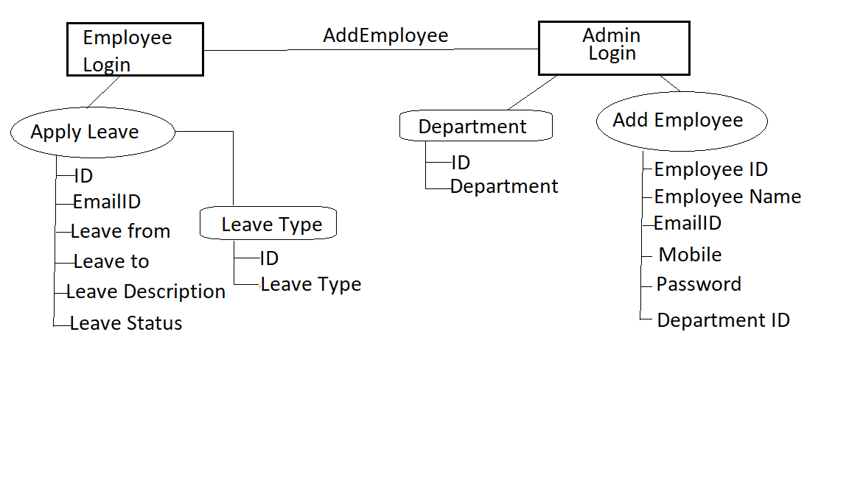

**1. Department Table:-**

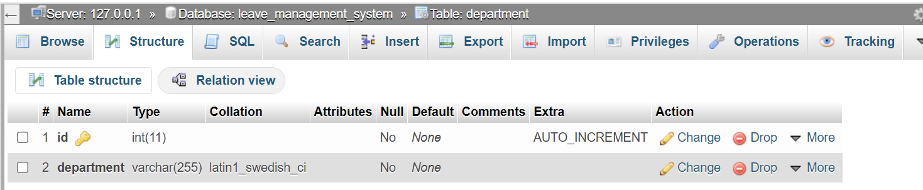

**2. Employee:-**

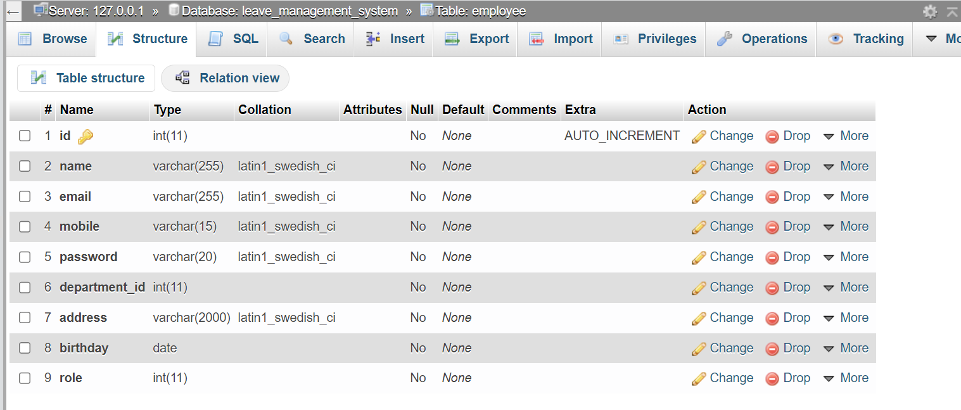

**3. Leave:-**

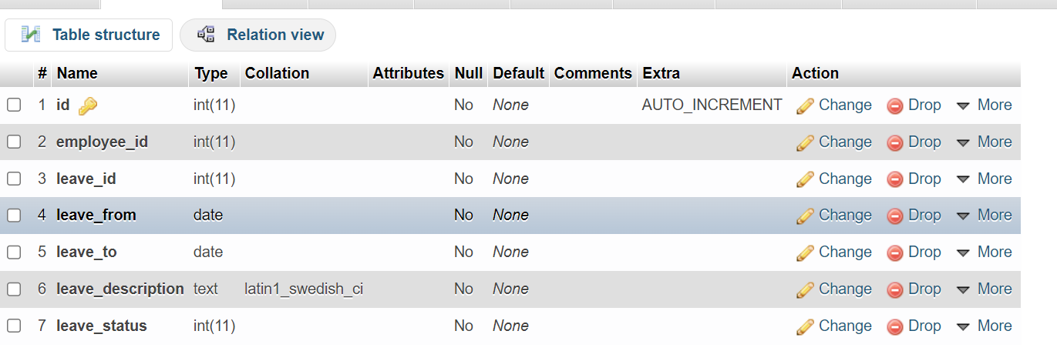

**4. Leave Type:-**

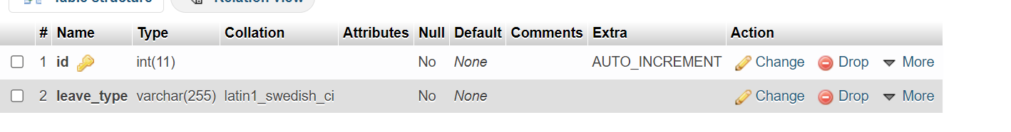

**Steps to go through Web App(LMS):-**

**1. Go to the browser:-**

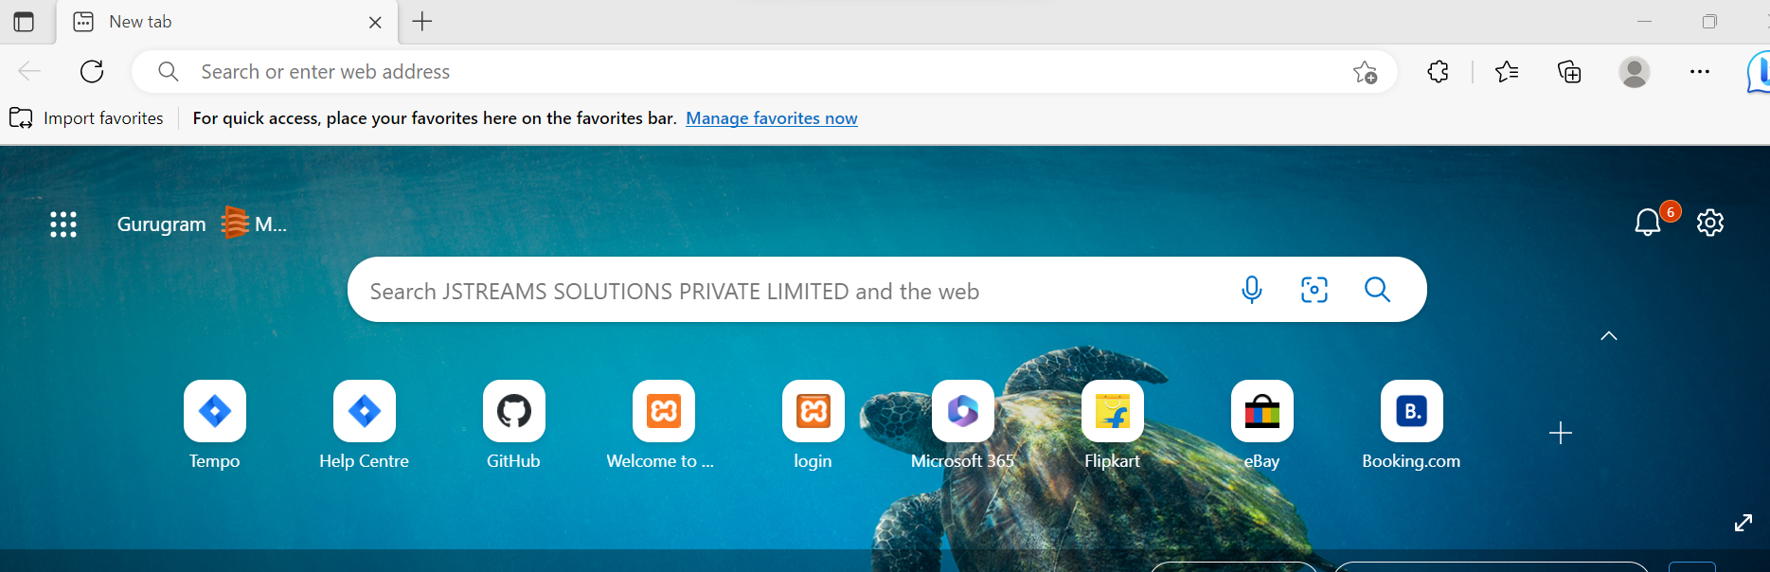

**2. Enter link** [**https://localhost/lmphp/**](https://localhost/lmphp/) **and press enter:-**

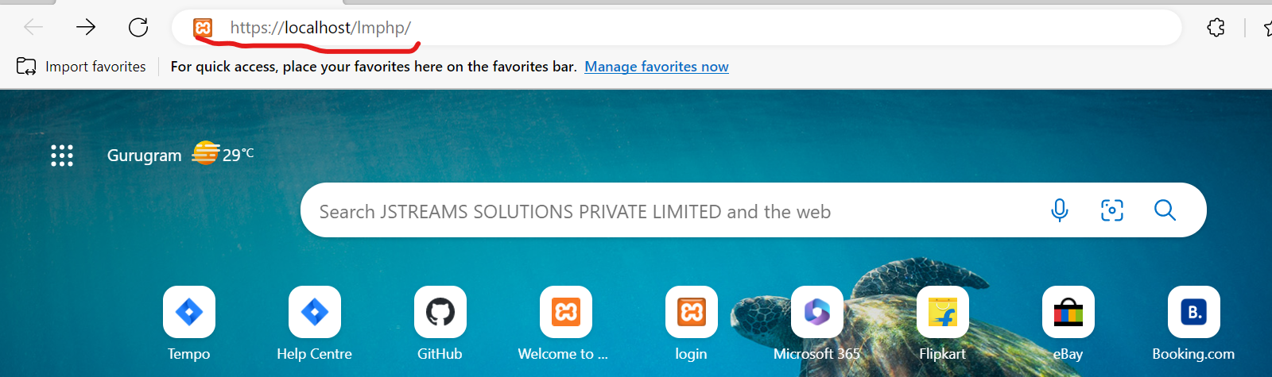

**3. You will be redirected to the login page:-**

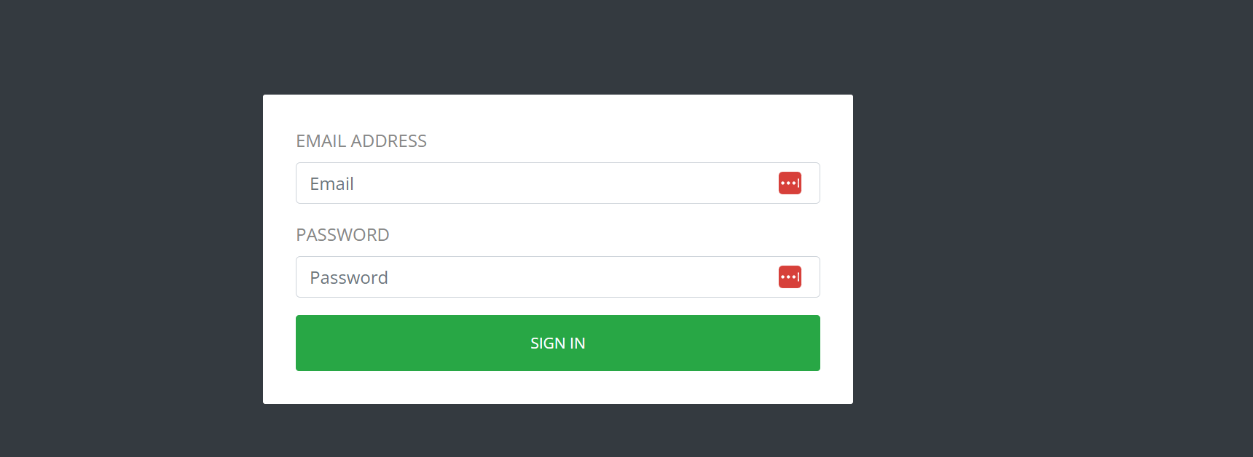

**4:-Entering Login Details for Admin:-**

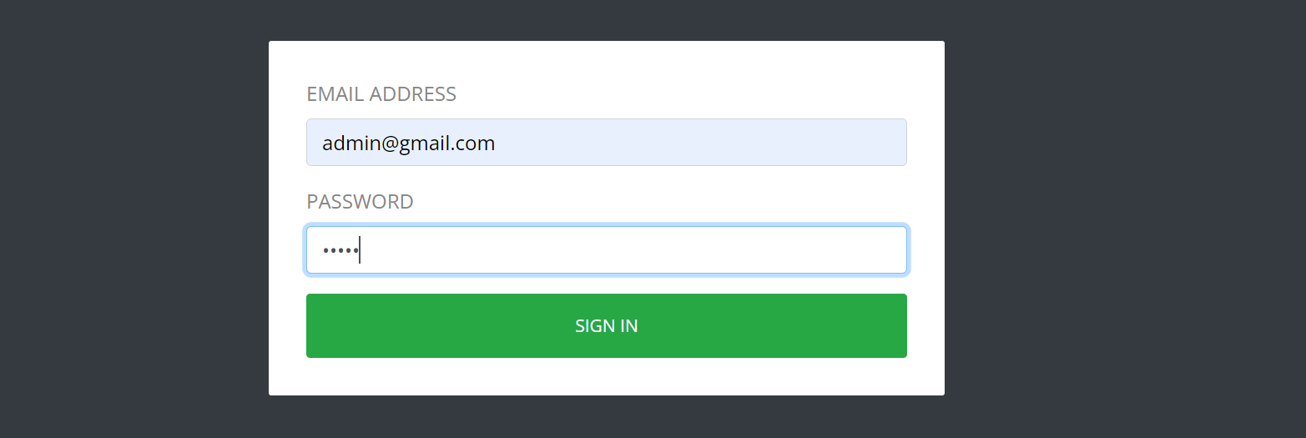

**5:- You will be redirected to Admin Dashboard:-**

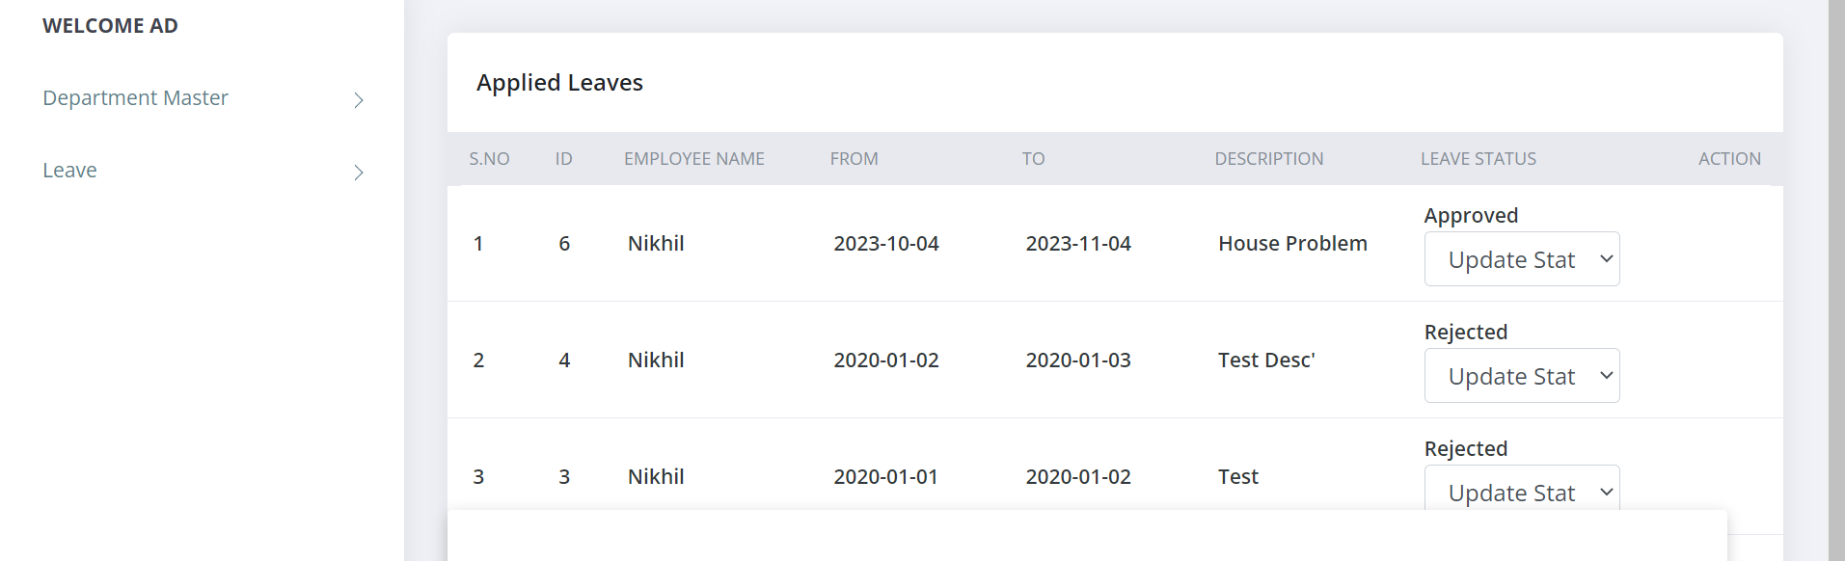

**6. Go to the Leave section:-**

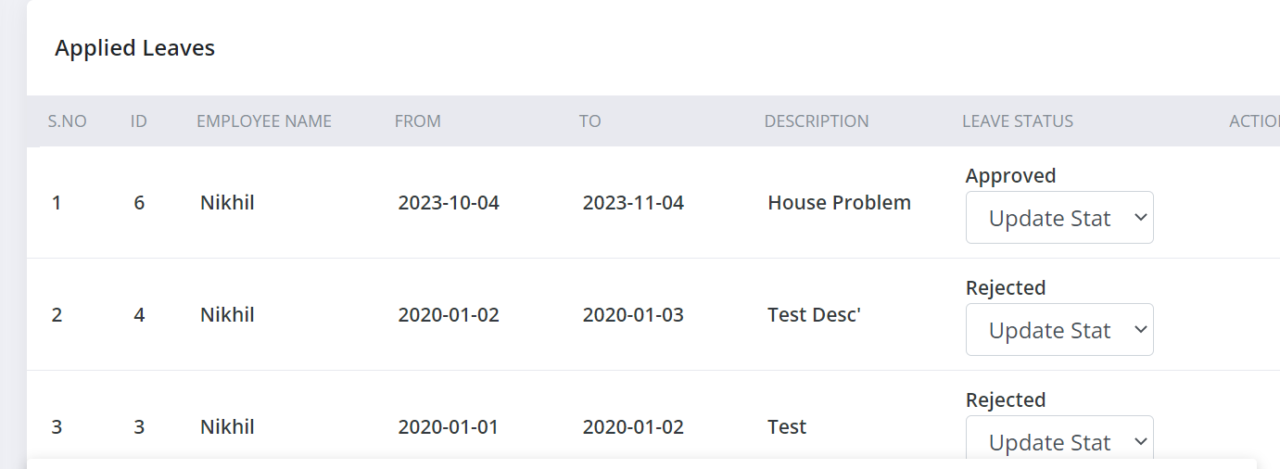

Now Admin can Approve/Reject Leaves applied by Employees.

**Employee Dashboard:**

**1. On logging in to Employee:-**

At this dashboard, employees can see the status of his/her leave applied before.

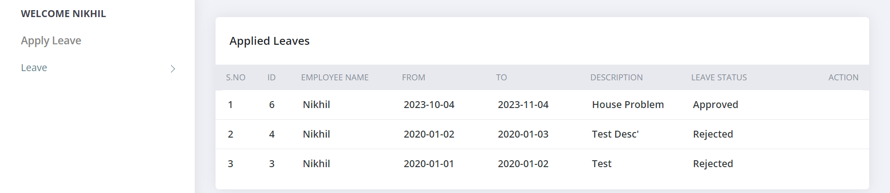

**2. On clicking on Apply leave section:-**

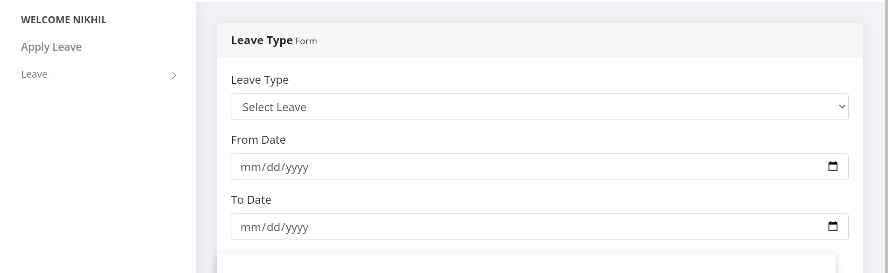

Here ,employees can apply for leave.

**THANK YOU**

**Regards TEAM-B**